Product Inventory System
Table: products (id, name, quantity, price)
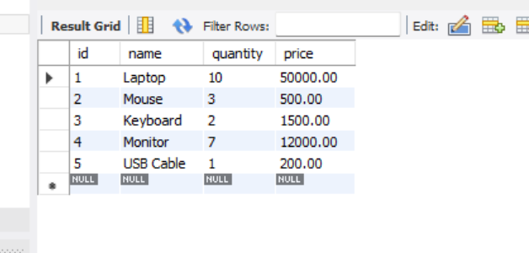
Tasks:
- Find low stock products (quantity < 5):
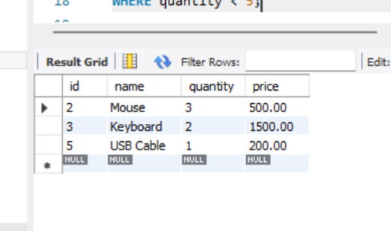

- Calculate total inventory value:
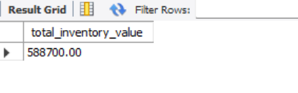

- Update stock after sale:
